Name – Yash Sasane

Roll No – 681

PRN – 202201050052

Batch – F(4)

# Essential of Data Science Lab Assignment No: 3

import numpy as np array1=np.array([[1,2,3],[4,5,6],[7,8,9]]) array1

## Output -

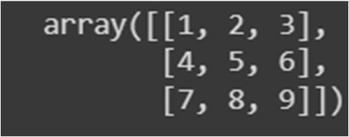

array2=np.array([[11,12,13],[14,15,16],[17,18,19]]) array2

## Output -

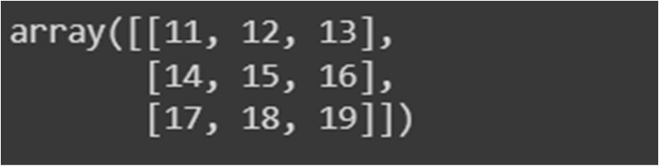

1. Matrix Operation

|  |
| --- |
| 1.1 Addition |
| resultarray=array1+array2 print("\nUsing Operator:\n",resultarray) resultarray=np.add(array1,array2) print("\nUsing Numpy Function:\n",resultarray) |

## Output -

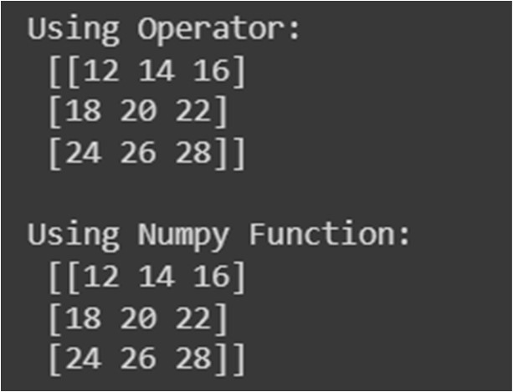

|  |
| --- |
| 1.2. Subtraction |
| resultarray=array1-array2 print("\nUsing Operator:\n",resultarray) resultarray=np.subtract(array1,array2) print("\nUsing Numpy Function:\n",resultarray) |

## Output -

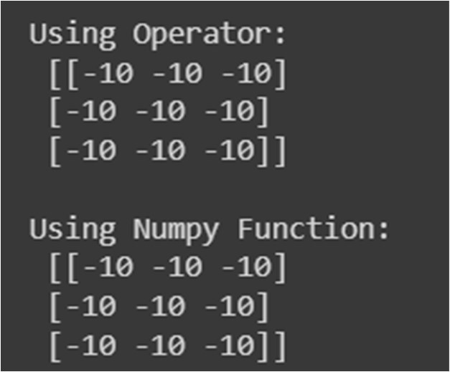

|  |
| --- |
| 1.3. Multiplication |
| resultarray=array1*array2 print("\nUsing Operator:\n",resultarray) resultarray=np.multiply(array1,array2) print("\nUsing Numpy Function:\n",resultarray) |

## Output –

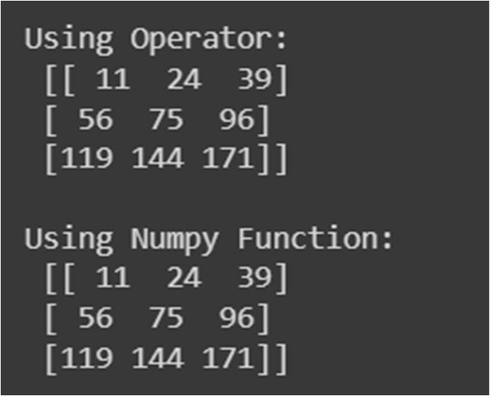

|  |
| --- |
| 1.4. Division |
| resultarray=array1/array2 print("\nUsing Operator:\n",resultarray) resultarray=np.divide(array1,array2) print("\nUsing Numpy Function:\n",resultarray) |

## Output –

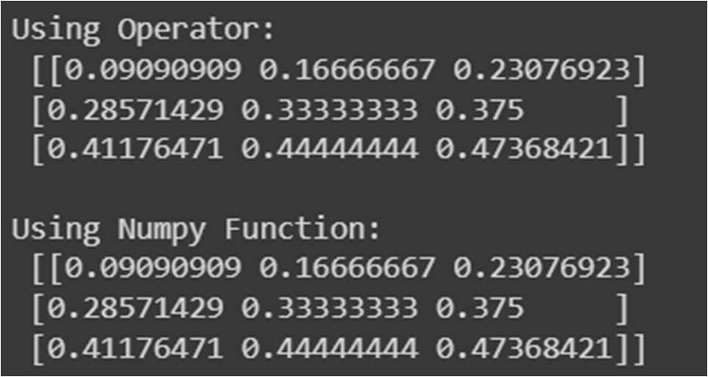

|  |
| --- |
| 1.5. Mod |
| resultarray=array1%array2 print("\nUsing Operator:\n",resultarray) resultarray=np.mod(array1,array2) print("\nUsing Numpy Function:\n",resultarray |

## Output –

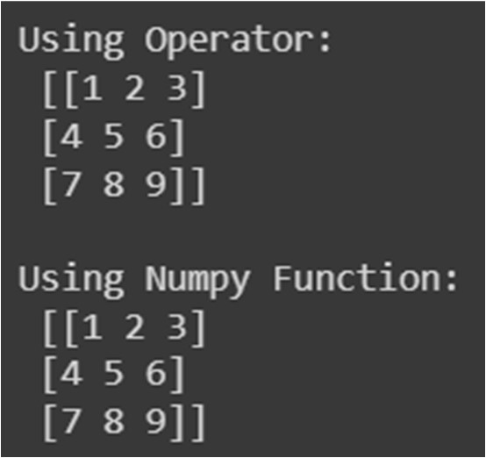

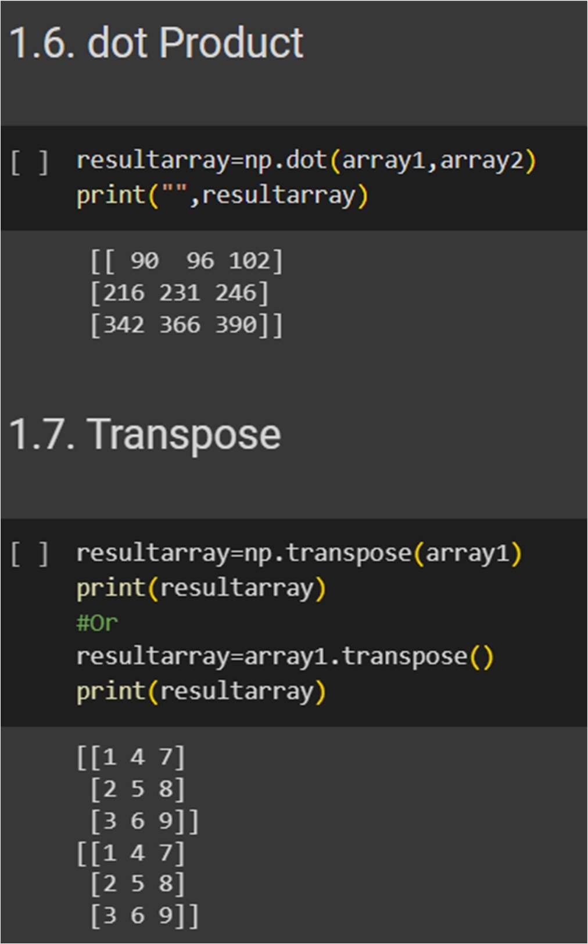

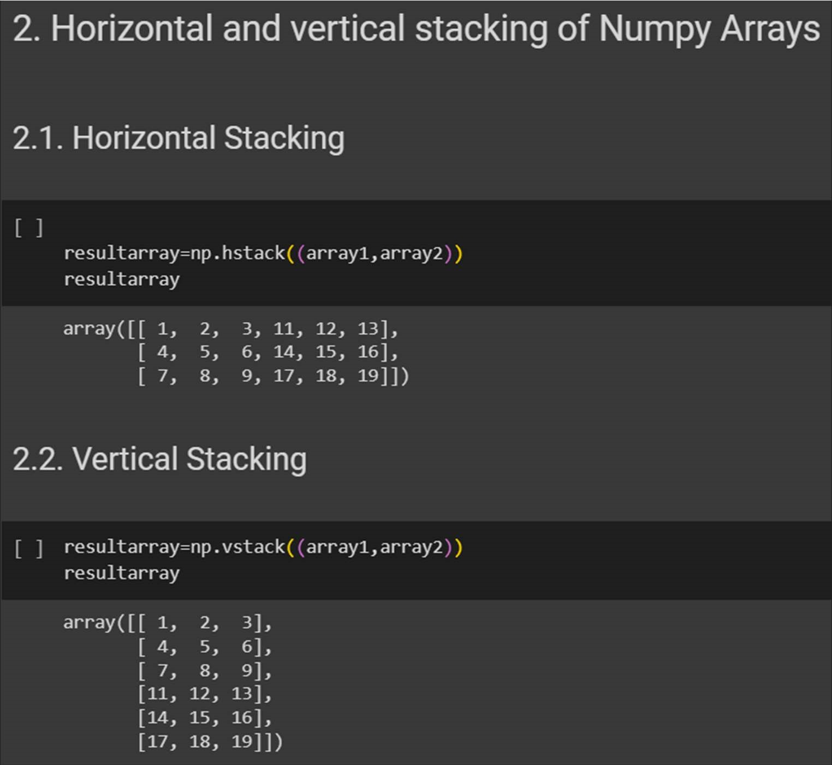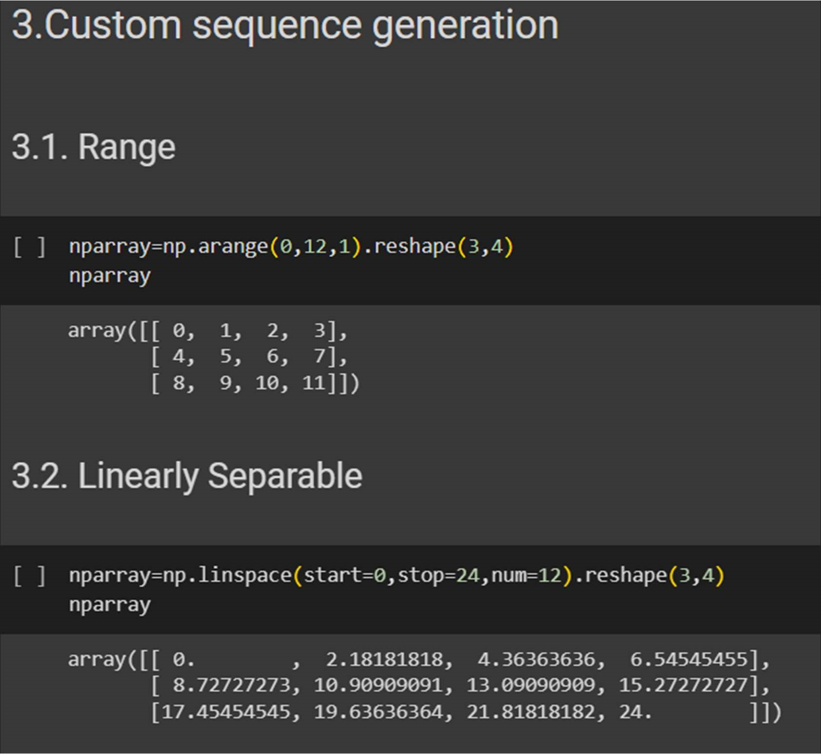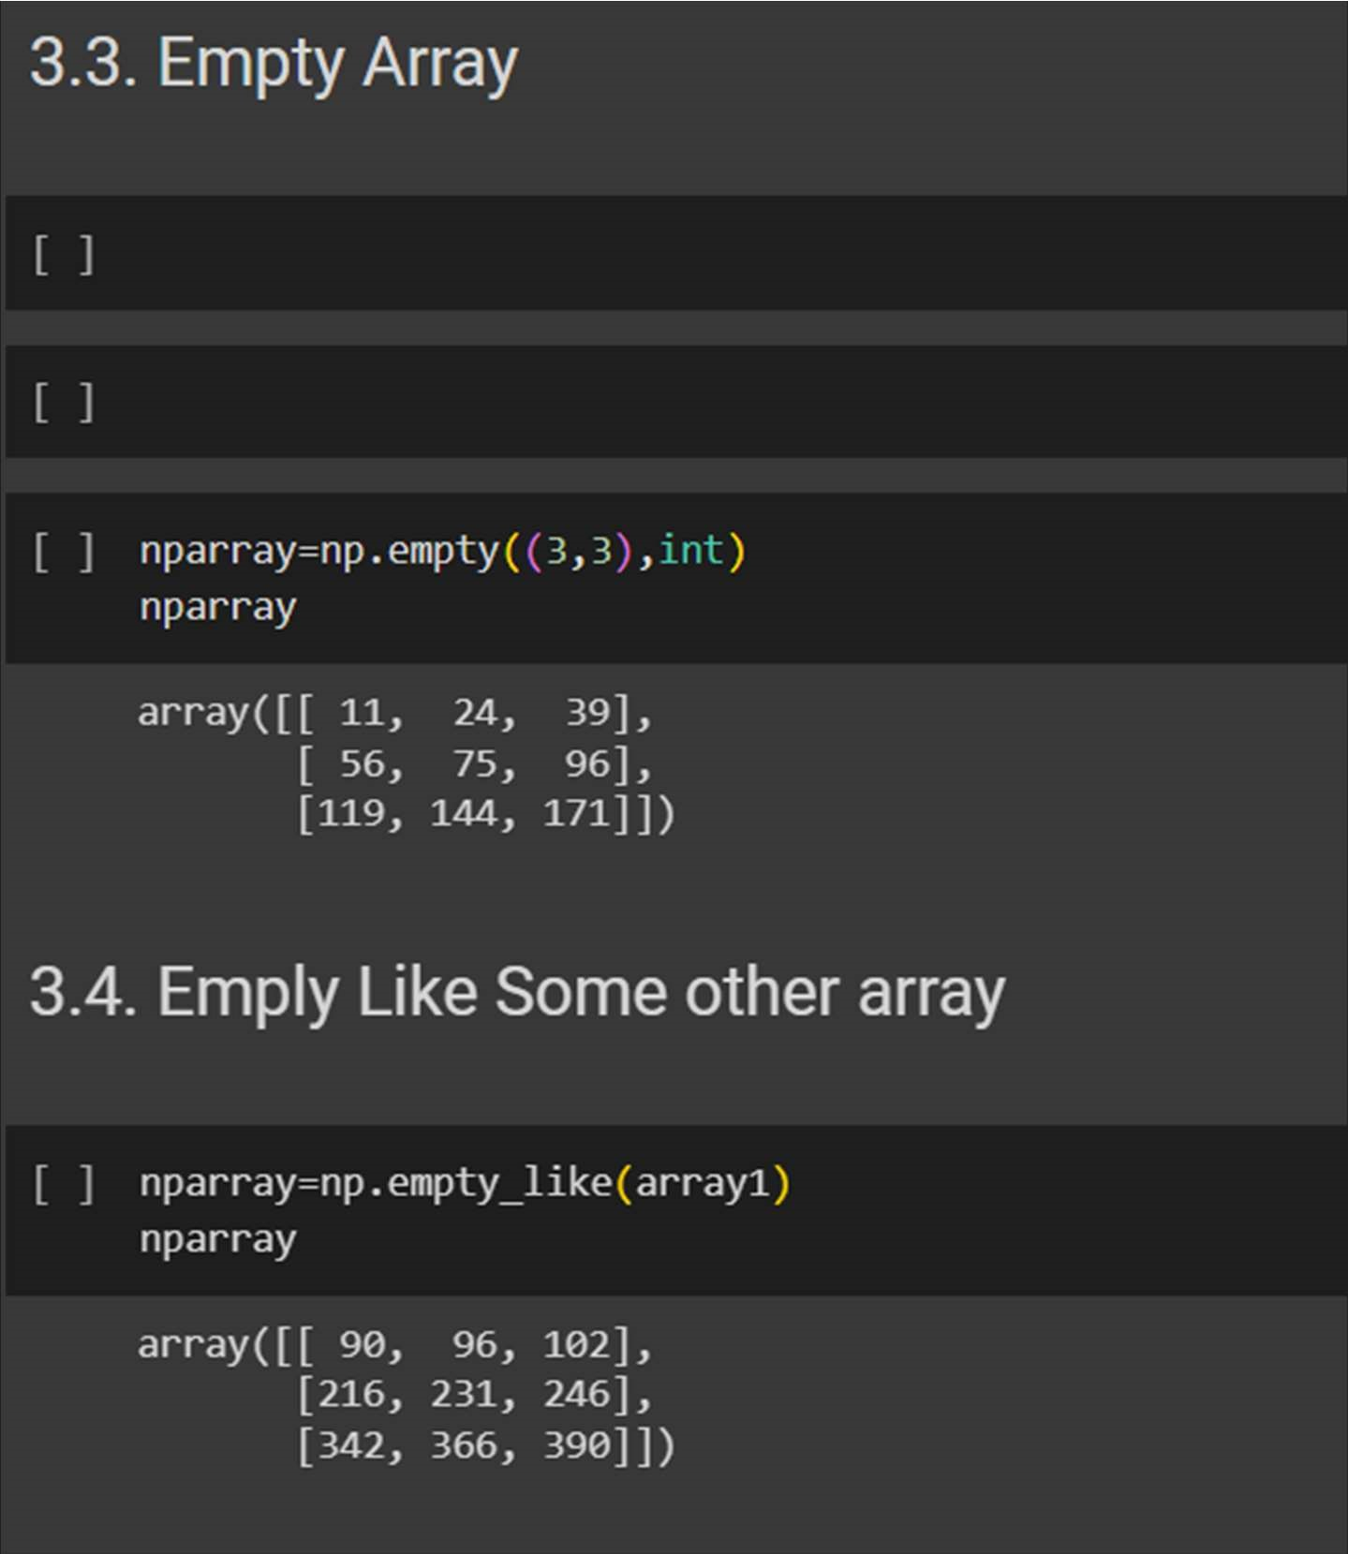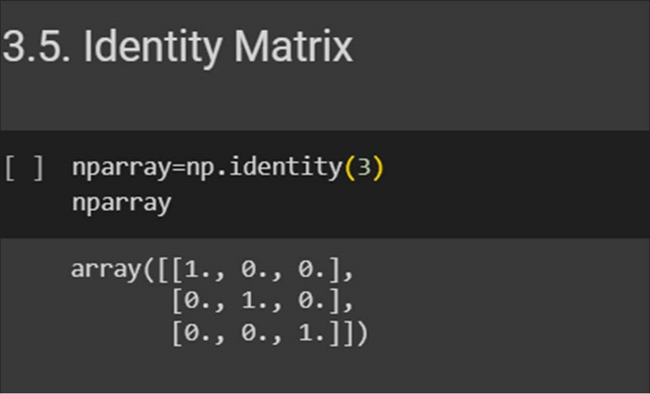

4. Arithmetic and Statistical Operations, Mathematical

Operations, Bitwise Operators

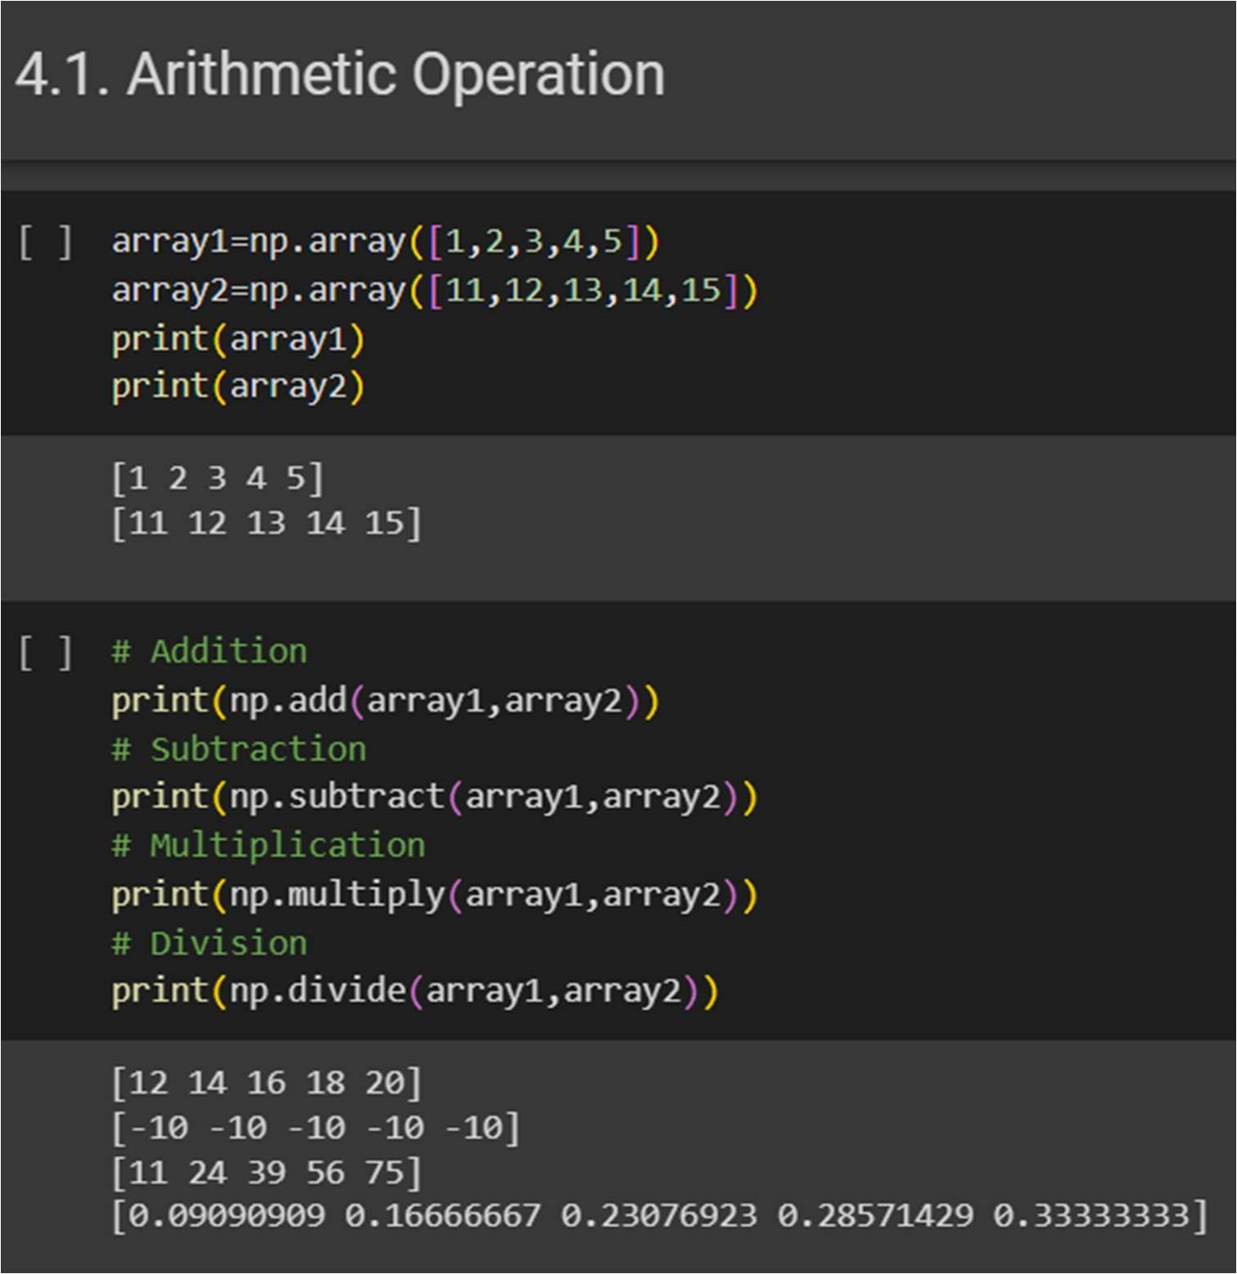

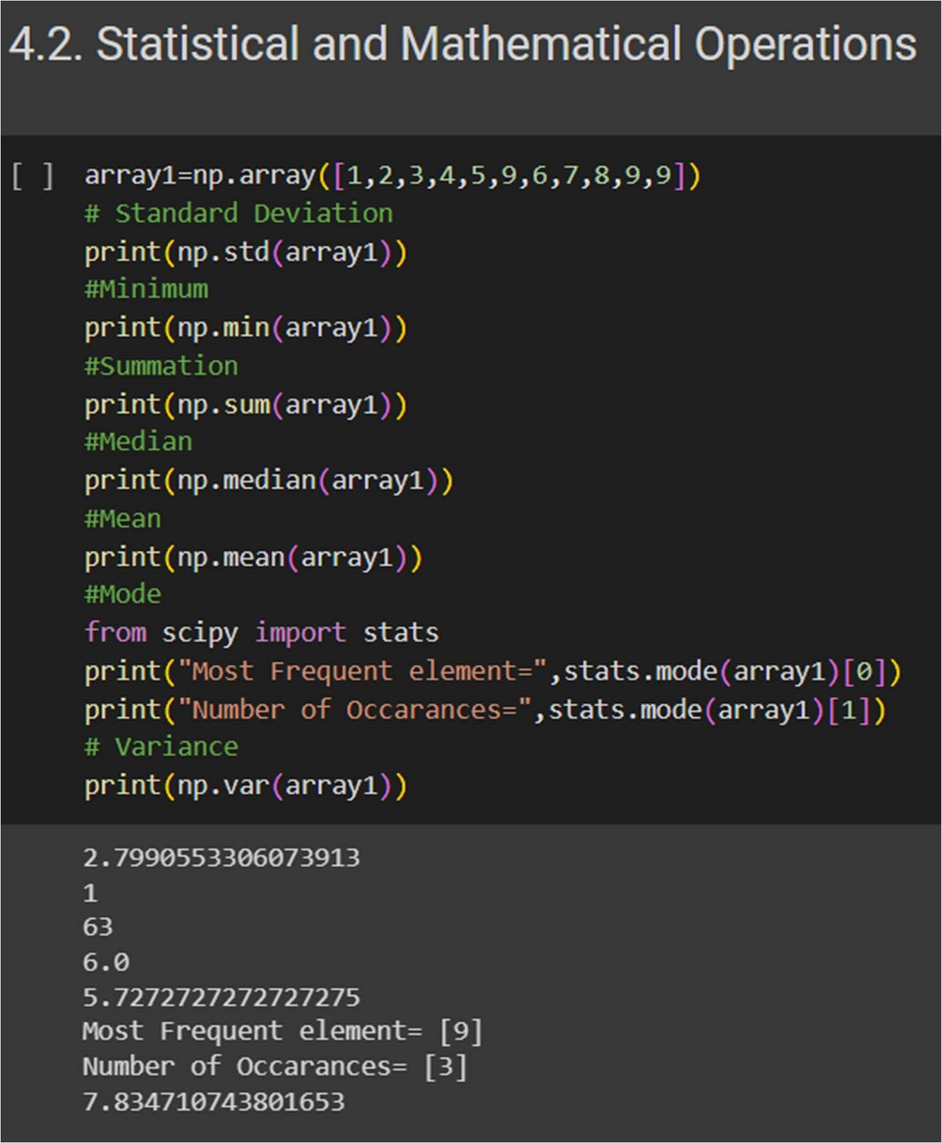

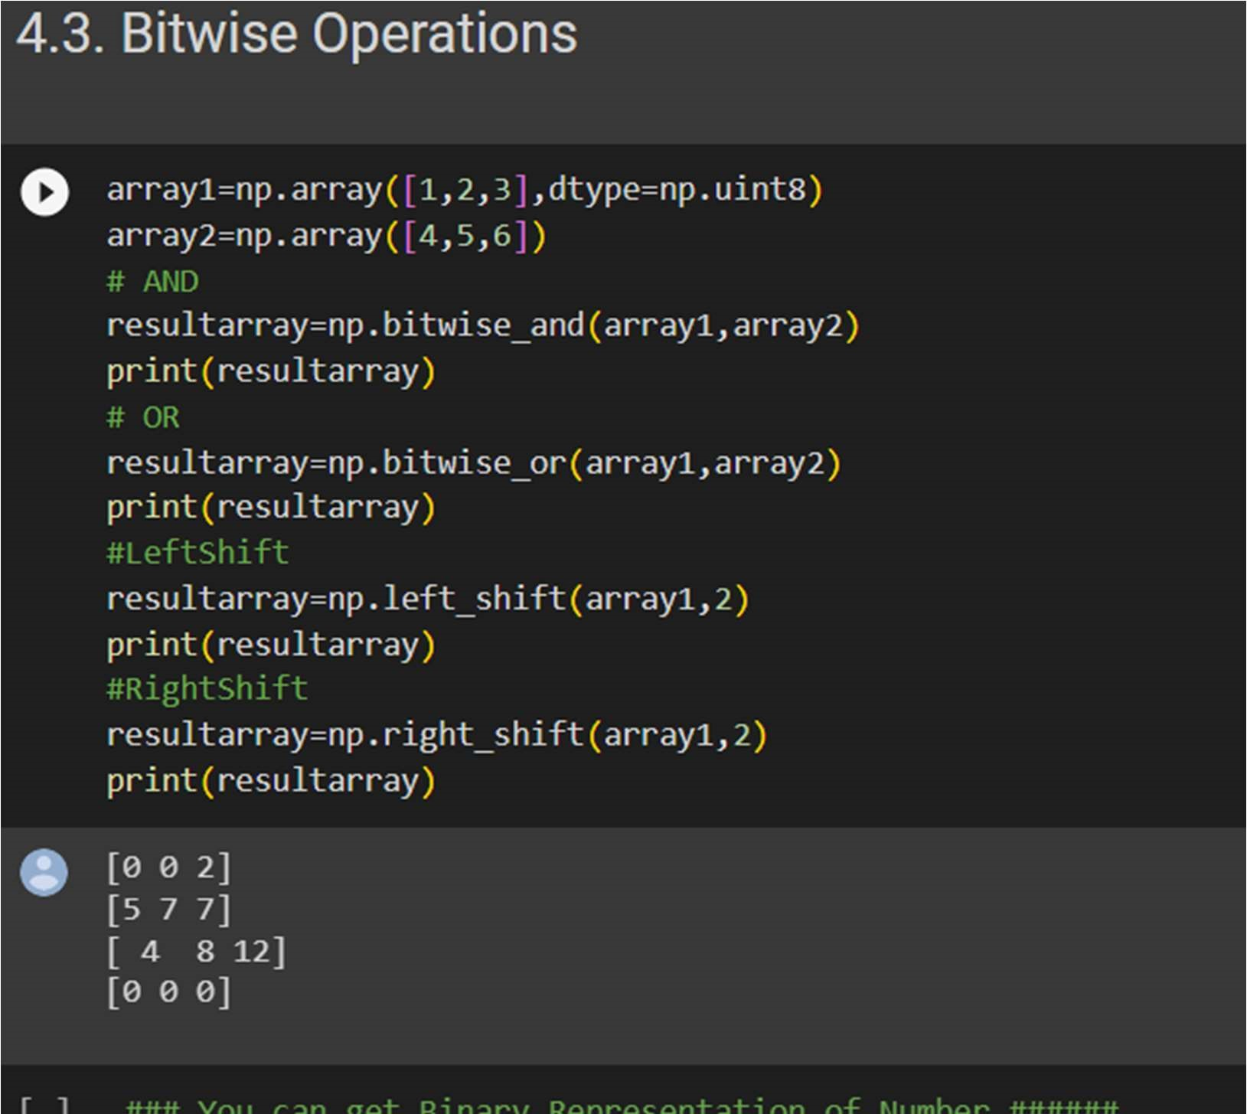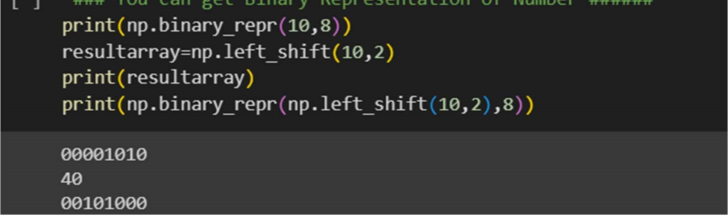

## 5.Copying and viewing arrays

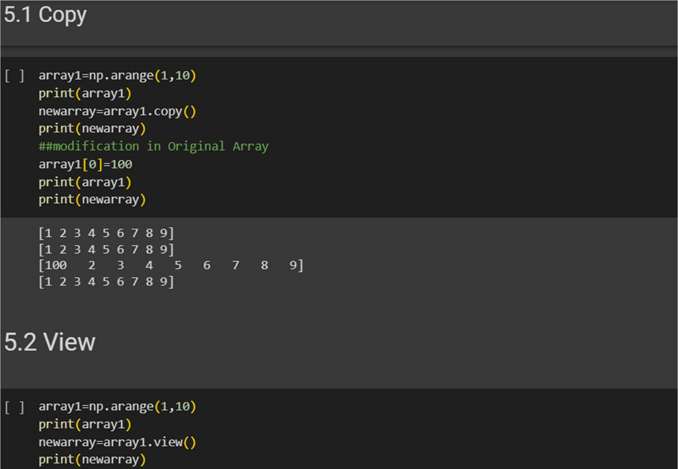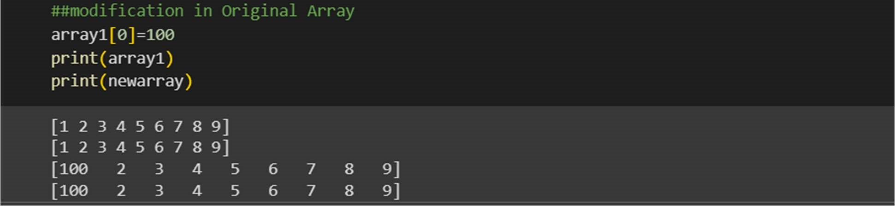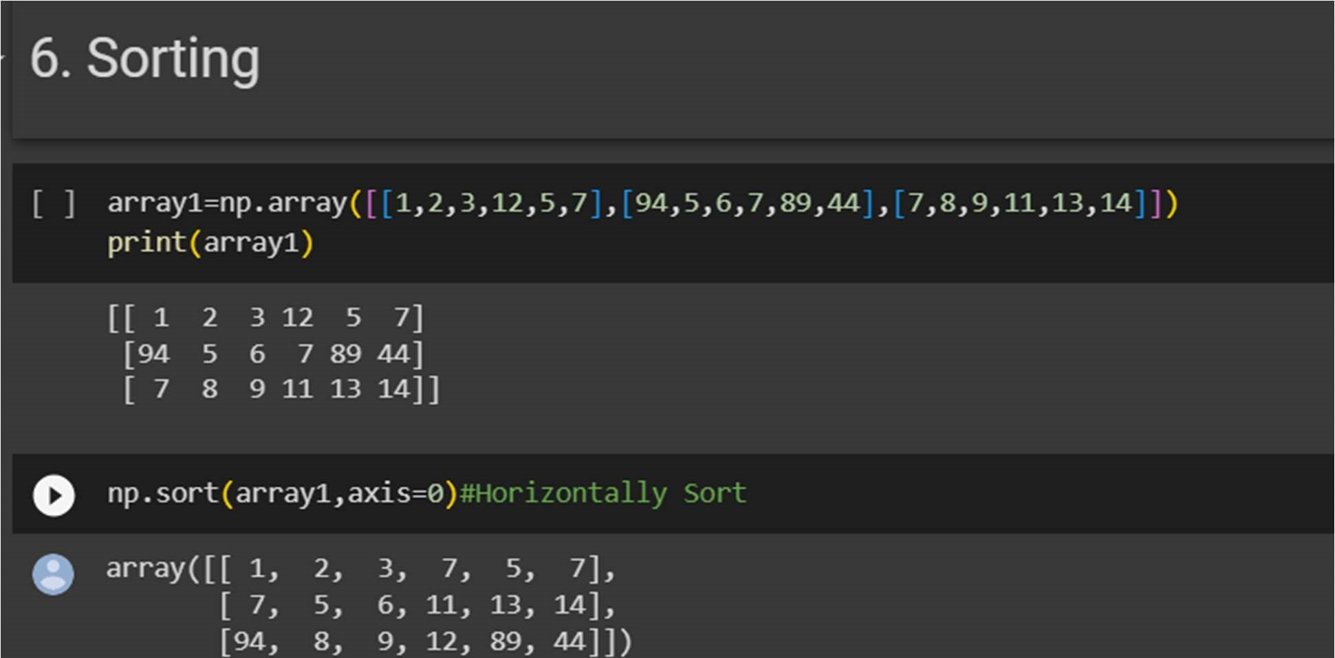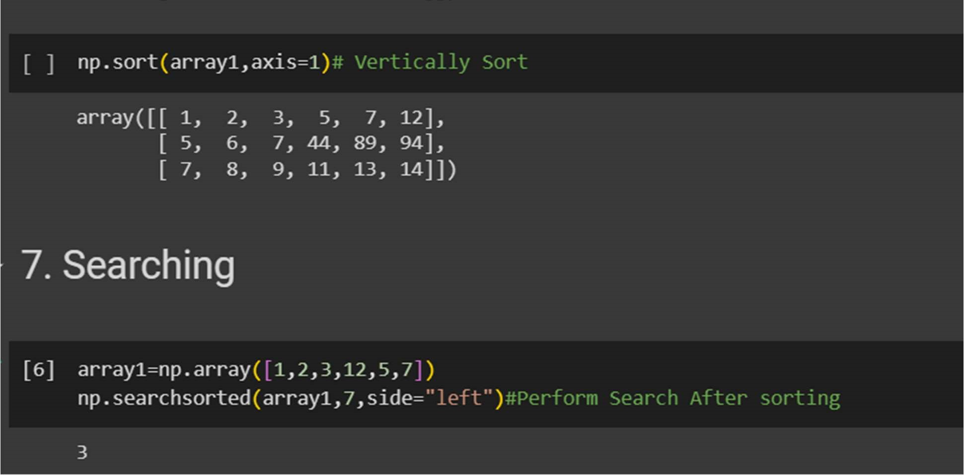

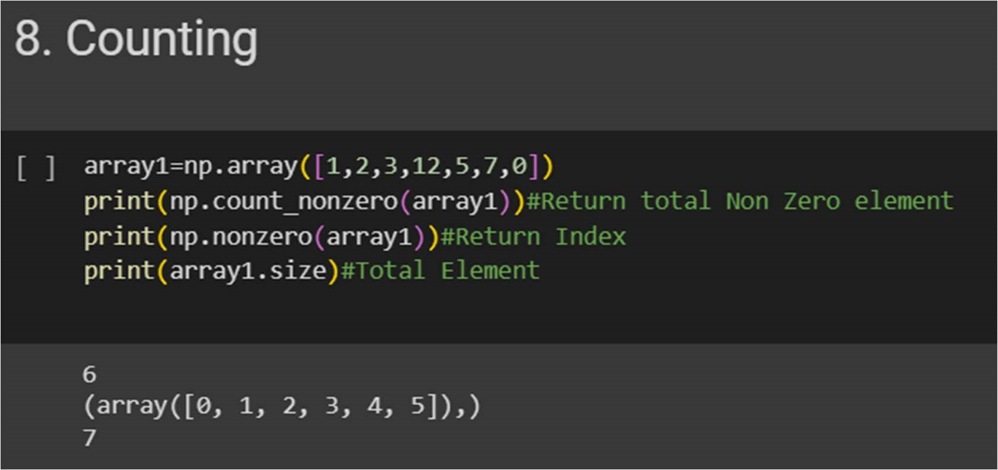

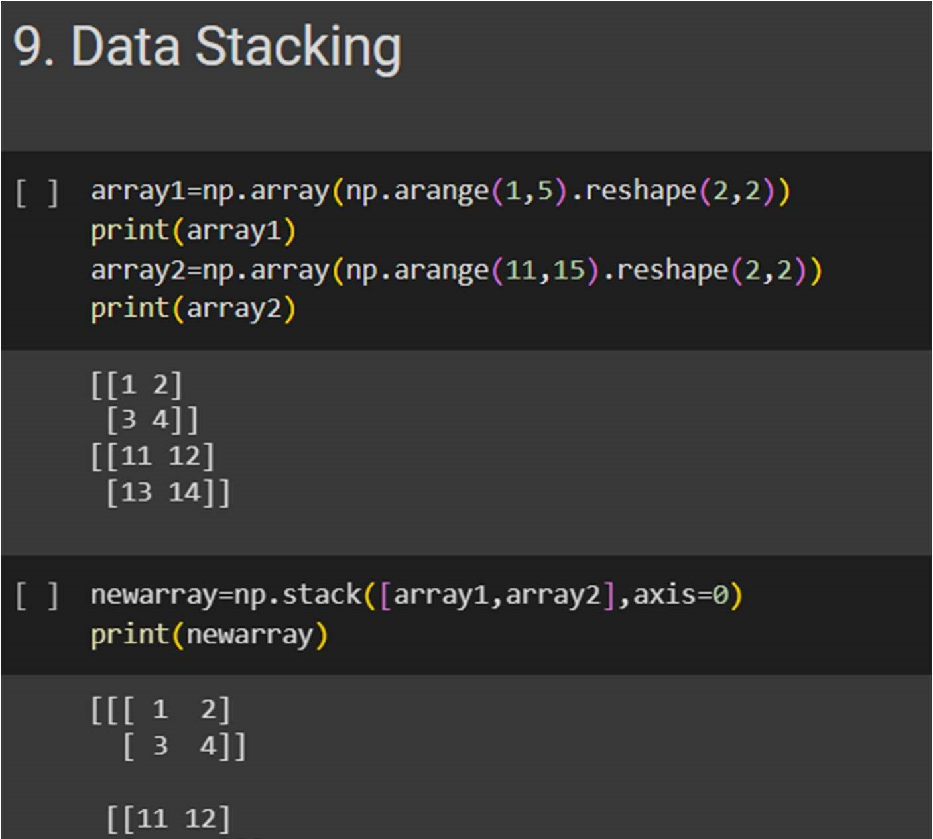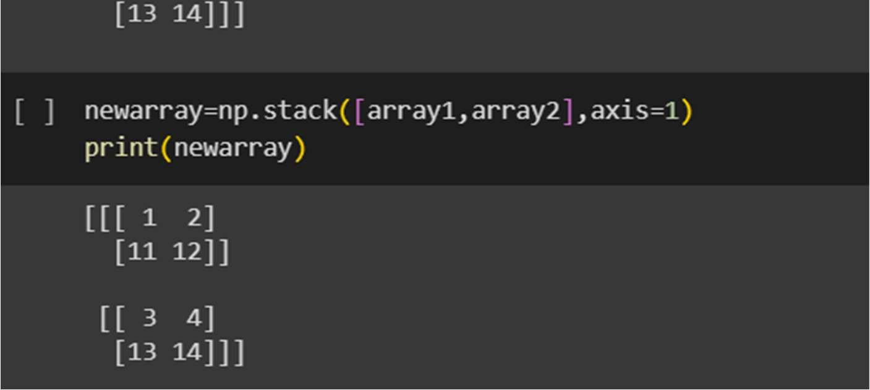

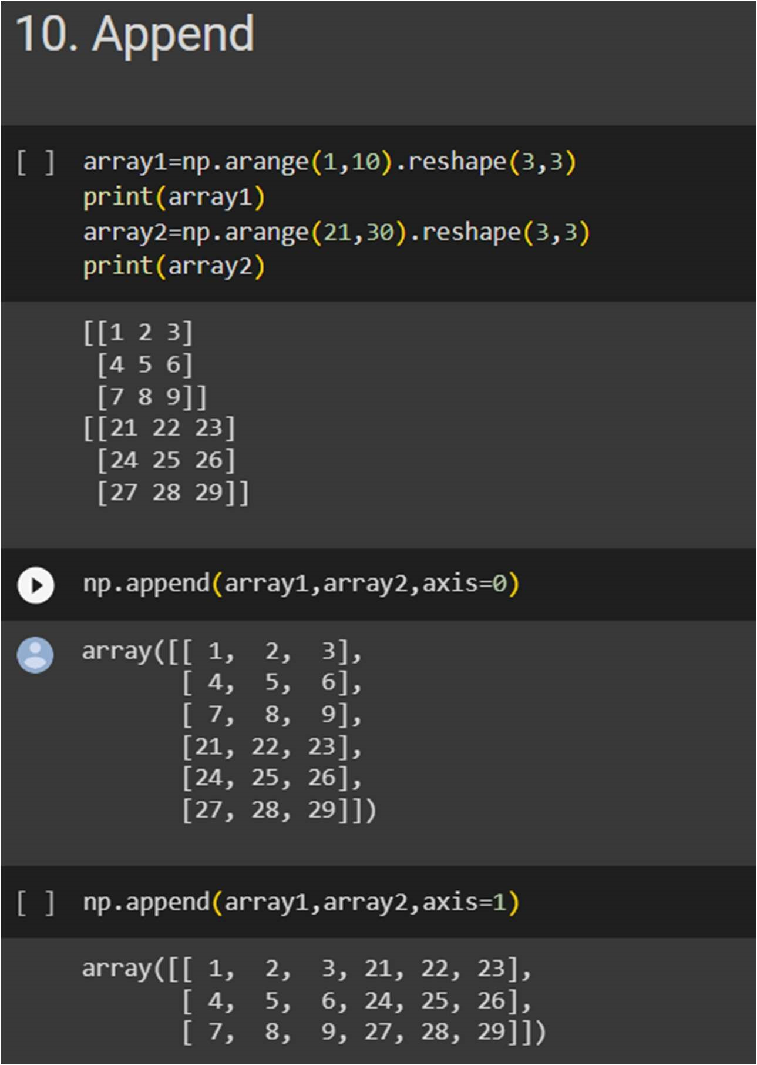

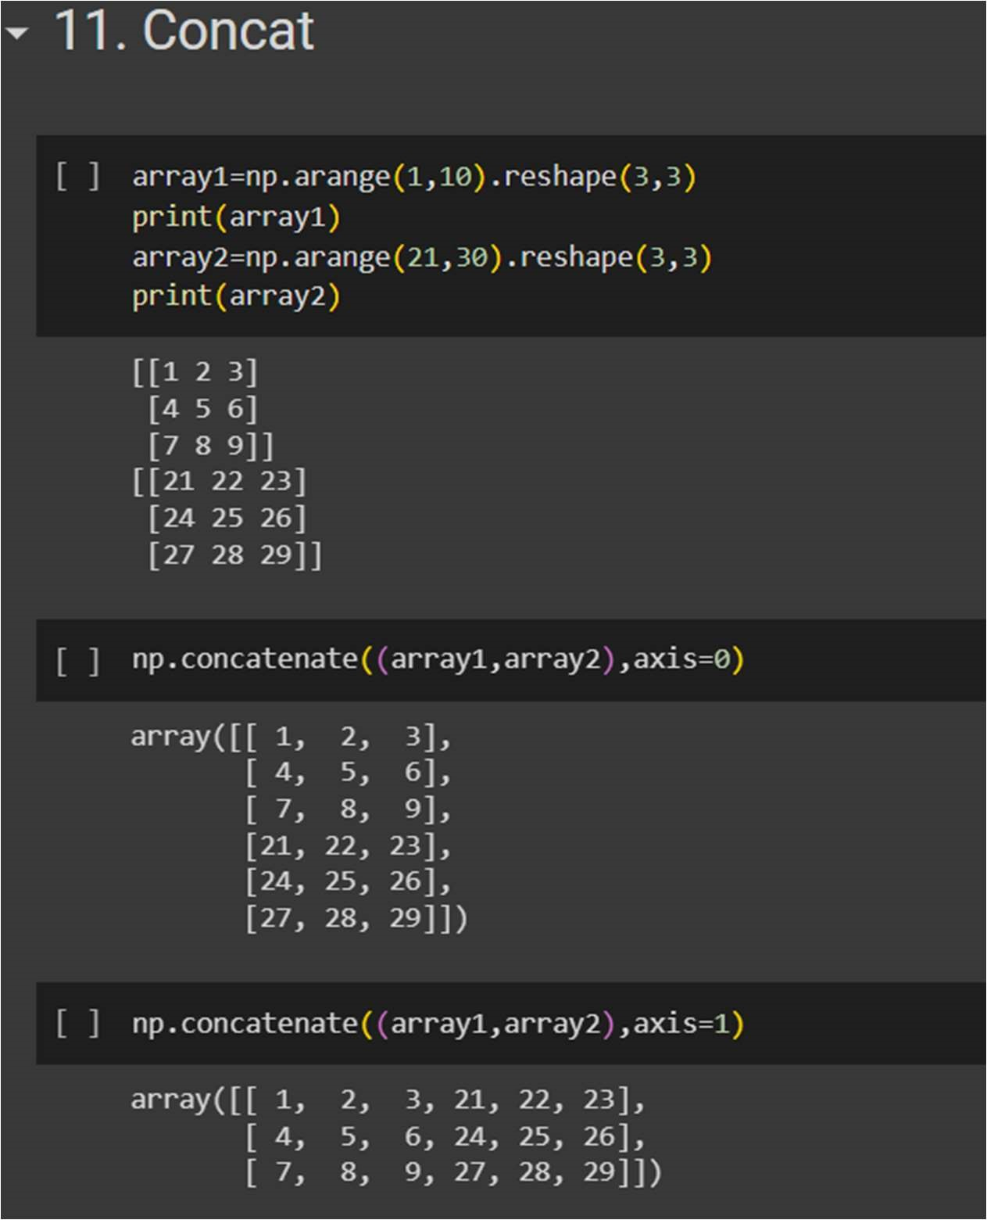

# 12.Broadcasting

